alpha = 0.00000005

training 1 epoch...

967.983758687973 seconds used......

1 training finished! average train loss: 0.18263751970424655

evaluating...

Confusion matrix, without normalization

[[ 83 185 26]

[ 72 3665 84]

[ 2 90 750]]

Normalized confusion matrix

[[0.28231293 0.6292517 0.08843537]

[0.01884323 0.95917299 0.02198377]

[0.0023753 0.10688836 0.89073634]]

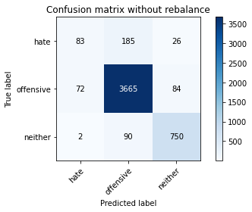

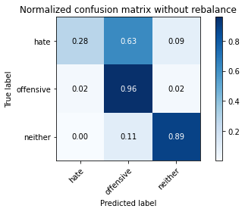

precision recall f1-score support

hate 0.53 0.28 0.37 294

offensive 0.93 0.96 0.94 3821

neither 0.87 0.89 0.88 842

accuracy 0.91 4957

macro avg 0.78 0.71 0.73 4957

weighted avg 0.90 0.91 0.90 4957

average eval_loss: 0.24919811573870962, accuracy: 0.9074036715755497

training 2 epoch...

988.4139077663422 seconds used......

2 training finished! average train loss: -0.4755495790912536

evaluating...

Confusion matrix, without normalization

[[ 18 249 27]

[ 4 3725 92]

[ 1 54 787]]

Normalized confusion matrix

[[0.06122449 0.84693878 0.09183673]

[0.00104685 0.97487569 0.02407747]

[0.00118765 0.06413302 0.93467933]]

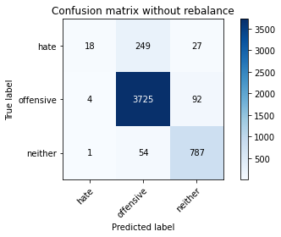

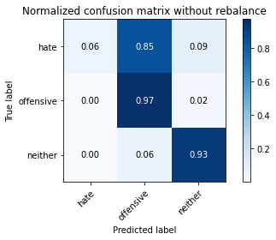

precision recall f1-score support

hate 0.78 0.06 0.11 294

offensive 0.92 0.97 0.95 3821

neither 0.87 0.93 0.90 842

accuracy 0.91 4957

macro avg 0.86 0.66 0.65 4957

weighted avg 0.91 0.91 0.89 4957

average eval_loss: 0.2545189959064667, accuracy: 0.9138591890256204

training 3 epoch...

988.0416095256805 seconds used......

3 training finished! average train loss: -1.7093922483969144

evaluating...

Confusion matrix, without normalization

[[ 100 181 13]

[ 80 3673 68]

[ 15 85 742]]

Normalized confusion matrix

[[0.34013605 0.61564626 0.04421769]

[0.02093693 0.96126668 0.01779639]

[0.01781473 0.10095012 0.88123515]]

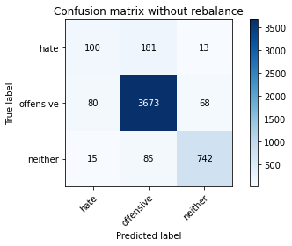

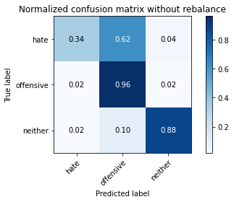

precision recall f1-score support

hate 0.51 0.34 0.41 294

offensive 0.93 0.96 0.95 3821

neither 0.90 0.88 0.89 842

accuracy 0.91 4957

macro avg 0.78 0.73 0.75 4957

weighted avg 0.90 0.91 0.91 4957

average eval_loss: 0.280070846184953, accuracy: 0.9108331652208997

training 4 epoch...

987.2614195346832 seconds used......

4 training finished! average train loss: -3.6179937240576057

evaluating...

Confusion matrix, without normalization

[[ 96 179 19]

[ 118 3636 67]

[ 19 78 745]]

Normalized confusion matrix

[[0.32653061 0.60884354 0.06462585]

[0.03088197 0.95158336 0.01753468]

[0.02256532 0.09263658 0.8847981 ]]

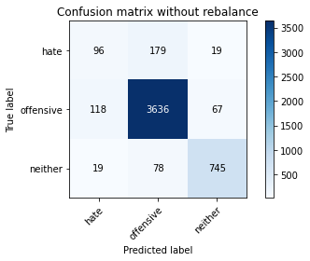

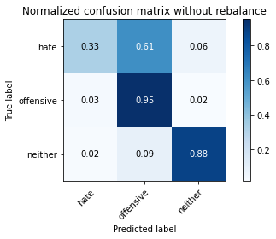

precision recall f1-score support

hate 0.41 0.33 0.36 294

offensive 0.93 0.95 0.94 3821

neither 0.90 0.88 0.89 842

accuracy 0.90 4957

macro avg 0.75 0.72 0.73 4957

weighted avg 0.90 0.90 0.90 4957

average eval_loss: 0.3239547054362183, accuracy: 0.9031672382489409

training 5 epoch...

986.7696290016174 seconds used......

5 training finished! average train loss: -6.302105548522476

evaluating...

Confusion matrix, without normalization

[[ 107 168 19]

[ 139 3613 69]

[ 16 83 743]]

Normalized confusion matrix

[[0.36394558 0.57142857 0.06462585]

[0.03637791 0.94556399 0.0180581 ]

[0.01900238 0.09857482 0.8824228 ]]

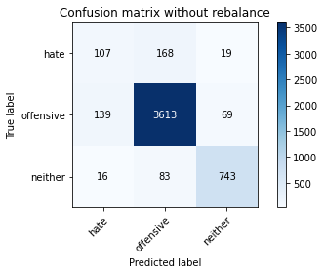

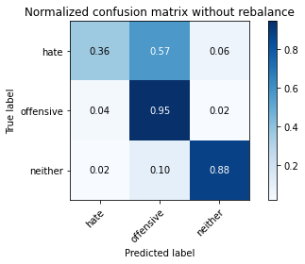

precision recall f1-score support

hate 0.41 0.36 0.38 294

offensive 0.94 0.95 0.94 3821

neither 0.89 0.88 0.89 842

accuracy 0.90 4957

macro avg 0.75 0.73 0.74 4957

weighted avg 0.90 0.90 0.90 4957

average eval_loss: 0.3776309565953617, accuracy: 0.900342949364535

training 6 epoch...

988.3541350364685 seconds used......

6 training finished! average train loss: -9.85923702934446

evaluating...

Confusion matrix, without normalization

[[ 136 140 18]

[ 205 3541 75]

[ 28 60 754]]

Normalized confusion matrix

[[0.46258503 0.47619048 0.06122449]

[0.05365088 0.92672075 0.01962837]

[0.03325416 0.07125891 0.89548694]]

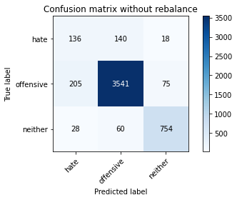

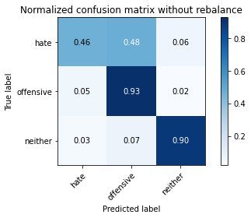

precision recall f1-score support

hate 0.37 0.46 0.41 294

offensive 0.95 0.93 0.94 3821

neither 0.89 0.90 0.89 842

accuracy 0.89 4957

macro avg 0.74 0.76 0.75 4957

weighted avg 0.90 0.89 0.90 4957

average eval_loss: 0.537153511821206, accuracy: 0.8938874319144644

training 7 epoch...

989.0064849853516 seconds used......

7 training finished! average train loss: -14.349462016928515

evaluating...

Confusion matrix, without normalization

[[ 105 174 15]

[ 111 3644 66]

[ 18 92 732]]

Normalized confusion matrix

[[0.35714286 0.59183673 0.05102041]

[0.02904999 0.95367705 0.01727297]

[0.02137767 0.10926366 0.86935867]]

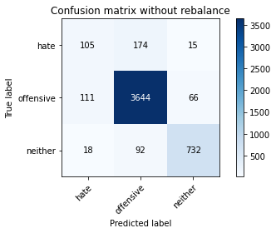

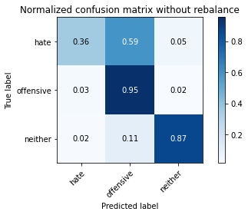

precision recall f1-score support

hate 0.45 0.36 0.40 294

offensive 0.93 0.95 0.94 3821

neither 0.90 0.87 0.88 842

accuracy 0.90 4957

macro avg 0.76 0.73 0.74 4957

weighted avg 0.90 0.90 0.90 4957

average eval_loss: 0.4248538966323043, accuracy: 0.9039741779301997

training 8 epoch...

987.73228764534 seconds used......

8 training finished! average train loss: -19.907638058299316

evaluating...

Confusion matrix, without normalization

[[ 72 202 20]

[ 63 3689 69]

[ 9 87 746]]

Normalized confusion matrix

[[0.24489796 0.68707483 0.06802721]

[0.01648783 0.96545407 0.0180581 ]

[0.01068884 0.10332542 0.88598575]]

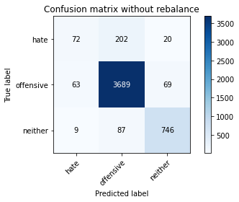

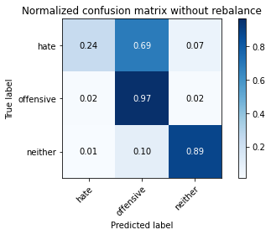

precision recall f1-score support

hate 0.50 0.24 0.33 294

offensive 0.93 0.97 0.95 3821

neither 0.89 0.89 0.89 842

accuracy 0.91 4957

macro avg 0.77 0.70 0.72 4957

weighted avg 0.90 0.91 0.90 4957

average eval_loss: 0.4589904917689461, accuracy: 0.9092192858583821

training 9 epoch...

987.3938341140747 seconds used......

9 training finished! average train loss: -26.616281514208666

evaluating...

Confusion matrix, without normalization

[[ 61 216 17]

[ 59 3719 43]

[ 18 139 685]]

Normalized confusion matrix

[[0.20748299 0.73469388 0.05782313]

[0.01544098 0.97330542 0.0112536 ]

[0.02137767 0.16508314 0.81353919]]

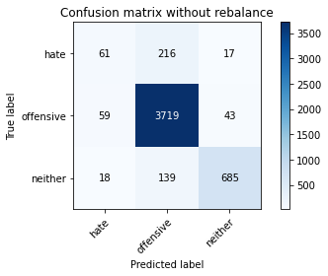

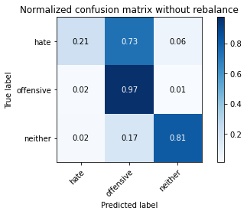

precision recall f1-score support

hate 0.44 0.21 0.28 294

offensive 0.91 0.97 0.94 3821

neither 0.92 0.81 0.86 842

accuracy 0.90 4957

macro avg 0.76 0.66 0.70 4957

weighted avg 0.89 0.90 0.89 4957

average eval_loss: 0.4847061141049527, accuracy: 0.9007464192051644

training 10 epoch...

988.8585851192474 seconds used......

10 training finished! average train loss: -34.549864543909024

evaluating...

Confusion matrix, without normalization

[[ 88 189 17]

[ 77 3690 54]

[ 20 117 705]]

Normalized confusion matrix

[[0.29931973 0.64285714 0.05782313]

[0.02015179 0.96571578 0.01413243]

[0.02375297 0.13895487 0.83729216]]

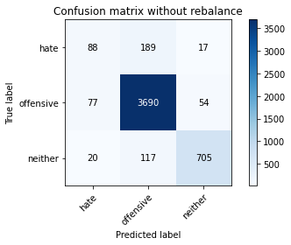

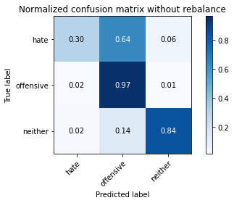

precision recall f1-score support

hate 0.48 0.30 0.37 294

offensive 0.92 0.97 0.94 3821

neither 0.91 0.84 0.87 842

accuracy 0.90 4957

macro avg 0.77 0.70 0.73 4957

weighted avg 0.89 0.90 0.90 4957

average eval_loss: 0.4483760703606681, accuracy: 0.9043776477708292